 TES
INSTRUMENTS

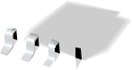
a
.

SN65HVD230
SN65HVD231
SN65HVD232

SLOS346G – MARCH 2001 – REVISED JUNE 2002

3.3-V CAN TRANSCEIVERS
FEATURES  ● Operates With a 3.3-V Supply  ● Low Power Replacement for the PCA82C250 Footprint  ● Bus/Pin ESD Protection Exceeds 16 kV HBM  ● High Input Impedance Allows for 120 Nodes on a Bus  ● Controlled Driver Output Transition Times for Improved Signal Quality on the SN65HVD230 and SN65HVD231  ● Unpowered Node Does Not Disturb the Bus  ● Compatible With the Requirements of the ISO 11898 Standard  ● Low-Current SN65HVD230 Standby Mode  370 μA Typical  ● Low-Current SN65HVD231 Sleep Mode  40 nA Typical  ● Designed for Signaling Rates† up to  1 Megabit/Second (Mbps)  ● Thermal Shutdown Protection  ● Open-Circuit Fail-Safe Design  ● Glitch-Free Power-Up and Power-Down Protection for Hot-Plugging Applications  LOGIC DIAGRAM (POSITIVE LOGIC)  SN65HVD230, SN65HVD231 Logic Diagram (Positive Logic) |  | APPLICATIONS  ● Motor Control  ● Industrial Automation  ● Basestation Control and Status  ● Robotics  ● Automotive  ● UPS Control  SN65HVD230D (Marked as VP230)  SN65HVD231D (Marked as VP231)  (TOP VIEW)
RS
8
7
6
5
1
2
3
4
D
GND
V CC
R
CANH
CANL
Vref
( )
SN65HVD232D Marked as VP232
(TOP VIEW)
NC
CANH
CANL
NC
D
GND
V CC
R
8
7
6
5
1
2
3
4
NC – No internal connection

SN65HVD232
Logic Diagram (Positive Logic)
5  3  V ref  V CC  1  D  8  RS  7  CANH  4  R  6  CANL |  | D  R | 1  4  CANH CANL  7  6
† The signaling rate of a line is the number of voltage transitions that are made per second expressed in the units bps (bits per second).
 | Please be aware that an important notice concerning availability, standard warranty, and use in critical applications of Texas Instruments semiconductor products and disclaimers thereto appears at the end of this data sheet.
TMS320Lx240x is a trademark of Texas Instruments.

PRODUCTION DATA information is current as of publication date. Products conform to specifications per the terms of Texas Instruments standard warranty. Production processing does not necessarily include testing of all parameters.

 TES
INSTRUMENTS
www.ti.com

Copyright ◎ 2002, Texas Instruments Incorporated

1

SN65HVD230
SN65HVD231
SN65HVD232
SLOS346G – MARCH 2001 – REVISED JUNE 2002

DESCRIPTION
The SN65HVD230, SN65HVD231, and SN65HVD232 controller area network (CAN) transceivers are designed for use with the Texas Instruments TMS320Lx240x刑 3.3-V DSPs with CAN controllers, or with equivalent devices. They are intended for use in applications employing the CAN serial communication physical layer in accordance with the ISO 11898 standard. Each CAN transceiver is designed to provide differential transmit capability to the bus and differential receive capability to a CAN controller at speeds up to 1 Mbps.
Designed for operation in especially-harsh environments, these devices feature cross-wire protection, loss-of-ground and overvoltage protection, overtemperature protection, as well as wide common-mode range. The transceiver interfaces the single-ended CAN controller with the differential CAN bus found in industrial, building automation, and automotive applications. It operates over a –2-V to 7-V common-mode range on the bus, and it can withstand common-mode transients of ± 25 V.
On the SN65HVD230 and SN65HVD231, pin 8 provides three different modes of operation: high-speed, slope control, and low-power modes. The high-speed mode of operation is selected by connecting pin 8 to ground, allowing the transmitter output transistors to switch on and off as fast as possible with no limitation on the rise and fall slopes. The rise and fall slopes can be adjusted by connecting a resistor to ground at pin 8, since the slope is proportional to the pin’s output current. This slope control is implemented with external resistor values of 10 kΩ, to achieve a 15-V/μs slew rate, to 100 kΩ, to achieve a 2-V/μs slew rate. See the Application Information section of this data sheet.
The circuit of the SN65HVD230 enters a low-current standby mode during which the driver is switched off and the receiver remains active if a high logic level is applied to pin 8. The DSP controller reverses this low-current standby mode when a dominant state (bus differential voltage > 900 mV typical) occurs on the bus.
The unique difference between the SN65HVD230 and the SN65HVD231 is that both the driver and the receiver are switched off in the SN65HVD231 when a high logic level is applied to pin 8 and remain in this sleep mode until the circuit is reactivated by a low logic level on pin 8.
The Vref pin 5 on the SN65HVD230 and SN65HVD231 is available as a V CC/2 voltage reference.
The SN65HVD232 is a basic CAN transceiver with no added options; pins 5 and 8 are NC, no connection.
AVAILABLE OPTIONS

PART NUMBER | LOW  POWER MODE | INTEGRATED SLOPE CONTROL | Vref PIN | TA | MARKED AS:
SN65HVD230 | Standby mode | Yes | Yes | – 40°C to 85°C | VP230
SN65HVD231 | Sleep mode | Yes | Yes | – 40°C to 85°C | VP231
SN65HVD232 | No standby or sleep mode | No | No | – 40°C to 85°C | VP232

Function Tables
DRIVER (SN65HVD230, SN65HVD231)

INPUT D | RS | OUTPUTS |  | BUS STATE
INPUT D | RS | CANH | CANL | BUS STATE
L | V(Rs) < 1.2 V | H | L | Dominant
H | V(Rs) < 1.2 V | Z | Z | Recessive
Open | X | Z | Z | Recessive
X | V(Rs) > 0.75 V CC | Z | Z | Recessive
H = high level; L = low level; X = irrelevant; ? = indeterminate; Z = high impedance
DRIVER (SN65HVD232)

INPUT D | OUTPUTS |  | BUS STATE
INPUT D | CANH | CANL | BUS STATE
L | H | L | Dominant
H | Z | Z | Recessive
Open | Z | Z | Recessive
H = high level; L = low level; Z = high impedance
RECEIVER (SN65HVD230)

DIFFERENTIAL INPUTS | RS | OUTPUT R
VID ≥ 0.9 V | X | L
0.5 V < VID < 0.9 V | X | ?
VID ≤ 0.5 V | X | H
Open | X | H
H = high level; L = low level; X = irrelevant; ? = indeterminate
RECEIVER (SN65HVD231)

DIFFERENTIAL INPUTS | RS | OUTPUT R
VID ≥ 0.9 V | V(Rs) < 1.2 V | L
0.5 V < VID < 0.9 V | V(Rs) < 1.2 V | ?
VID ≤ 0.5 V | V(Rs) < 1.2 V | H
X | V(Rs)> 0.75 V CC | H
X | 1.2 V < V(Rs) < 0.75 V CC | ?
Open | X | H
H = high level; L = low level; X = irrelevant; ? = indeterminate
RECEIVER (SN65HVD232)

DIFFERENTIAL INPUTS | OUTPUT R
VID ≥ 0.9 V | L
0.5 V < VID < 0.9 V | ?
VID ≤ 0.5 V | H
Open | H
H = high level; L = low level; X = irrelevant; ? = indeterminate

Function Tables (Continued)
TRANSCEIVER MODES (SN65HVD230, SN65HVD231)

V(Rs) | OPERATING MODE
V(Rs)> 0.75 V CC | Standby
10 kΩ to 100 kΩ to ground | Slope control
V(Rs) < 1 V | High speed (no slope control)

Terminal Functions

SN65HVD230, SN65HVD231

TERMINAL  NAME NO. | DESCRIPTION
CANL 6 | Low bus output
CANH 7 | High bus output
D 1 | Driver input
GND 2 | Ground
R 4 | Receiver output
RS 8 | Standby/slope control
V CC 3 | Supply voltage
Vref 5 | Reference output

SN65HVD232

TERMINAL  NAME NO. | DESCRIPTION
CANL 6 | Low bus output
CANH 7 | High bus output
D 1 | Driver input
GND 2 | Ground
NC 5, 8 | No connection
R 4 | Receiver output
V CC 3 | Supply voltage

equivalent input and output schematic diagrams

CANH and CANL Inputs
V CC
Input
Input
16 V 110 kΩ 9 kΩ
45 kΩ

20 V 9 kΩ

D Input

100 kΩ
1 kΩ

9 V
V CC

CANH and CANL Outputs

V CC
V CC

16 V

Output

20 V

R Output

5 Ω
Output

9 V

absolute maximum ratings over operating free-air temperature (see Note 1) (unless otherwise

noted)†

Supply voltage range, V CC –0.3 V to 6 V
Voltage range at any bus terminal (CANH or CANL) –4 V to 16 V
Voltage input range, transient pulse, CANH and CANL, through 100 Ω (see Figure 7) –25 V to 25 V
Input voltage range, VI (D or R) –0.5 V to V CC + 0.5 V
Electrostatic discharge: Human body model (see Note 2) CANH, CANL and GND 16 kV
All Pins 4 kV
Charged-device model (see Note 3) All pins 1 kV
Continuous total power dissipation See Dissipation Rating table
Storage temperature range, Tstg . . . . . . . . . . . . . . . . . . . . . . . . . . . . . . . . . . . . . . . . . . . . . . . . . . . . . . . . –65°C to 150°C
Lead temperature 1,6 mm (1/16 inch) from case for 10 seconds 260°C
† Stresses beyond those listed under“absolute maximum ratings” may cause permanent damage to the device. These are stress ratings only, and
functional operation of the device at these or any other conditions beyond those indicated under “recommended operating conditions” is not
implied. Exposure to absolute-maximum-rated conditions for extended periods may affect device reliability.
NOTES: 1. All voltage values, except differential I/O bus voltages, are with respect to network ground terminal.
2. Tested in accordance with JEDEC Standard 22, Test Method A114-A.
3. Tested in accordance with JEDEC Standard 22, Test Method C101.
DISSIPATION RATING TABLE

PACKAGE | TA ≤ 25°C | DERATING FACTOR‡ | TA = 70°C | TA = 85°C
PACKAGE | POWER RATING | ABOVE TA = 25°C | POWER RATING | POWER RATING
D | 725 mW | 5.8 mW/°C | 464 mW | 377 mW
丰 This is the inverse of the junction-to-ambient thermal resistance when board-mounted and with no air flow.

recommended operating conditions

PARAMETER |  | MIN NOM MAX | UNIT
Supply voltage, V CC |  | 3 3.6 | V
Voltage at any bus terminal (common mode) VIC |  | – 2§ 7 | V
Voltage at any bus terminal (separately) VI |  | – 2.5 7.5 | V
High-level input voltage, VIH | D, R | 2 | V
Low-level input voltage, VIL | D, R | 0.8 | V
Differential input voltage, VID (see Figure 5) |  | –6 6 | V
Input voltage, V(Rs) |  | 0 V CC | V
Input voltage for standby or sleep, V(Rs) |  | 0.75 VCC V CC | V
Wave-shaping resistance, Rs |  | 0 100 | kΩ
High-level output current, IOH | Driver | –40 | mA
High-level output current, IOH | Receiver | –8 | mA
Low-level output current, IOL | Driver | 48 | mA
Low-level output current, IOL | Receiver | 8 | mA
Operating free-air temperature, TA |  | –40 85 | °C
§ The algebraic convention, in which the least positive (most negative) limit is designated as minimum is used in this data sheet.

driver electrical characteristics over recommended operating conditions (unless otherwise noted)

PARAMETER |  |  |  | TEST CONDITIONS |  | MIN TYP† MAX | UNIT
VOH | Bus output voltage | Dominant |  | VI = 0 V,  See Figure 1 and Figure 3 | CANH | 2.45 V CC | V
 |  |  |  |  | CANL | 0.5 1.25 | V
VOL | Bus output voltage | Recessive |  | VI = 3 V,  See Figure 1 and Figure 3 | CANH | 2.3 | V
 |  |  |  |  | CANL | 2.3 | V
VOD(D) | Differential output voltage | Dominant |  | VI = 0 V, See Figure 1 |  | 1.5 2 3 | V
VOD(D) | Differential output voltage |  |  | VI = 0 V, See Figure 2 |  | 1.2 2 3 | V
VOD(R) | Differential output voltage | Recessive |  | VI = 3 V, See Figure 1 |  | – 120 0 12 | mV
VOD(R) | Differential output voltage |  |  | VI = 3 V, No load |  | – 0.5 – 0.2 0.05 | V
IIH High-level input current |  |  |  | VI = 2 V |  | – 30 | μA
IIL Low-level input current |  |  |  | VI = 0.8 V |  | – 30 | μA
IOS Short-circuit output current |  |  |  | VCANH = –2 V |  | – 250 250 | mA
 |  |  |  | VCANL = 7 V |  | – 250 250 | mA
Co Output capacitance |  |  |  | See receiver
ICC Supply current |  | Standby | SN65HVD230 | V(Rs) = V CC |  | 370 600 | μA
 |  | Sleep | SN65HVD231 | V(Rs) = V CC, D at V CC |  | 0.04 1 | μA
 |  | All devices | Dominant | VI = 0 V, No load | Dominant | 10 17 | mA
 |  | All devices | Recessive | VI = V CC , No load | Recessive | 10 17 | mA
† All typical values are at 25°C and with a 3.3-V supply.

driver switching characteristics over recommended operating conditions(unless otherwise noted)

SN65HVD230 and SN65HVD231

PARAMETER |  | TEST  CONDITIONS | MIN TYP MAX | UNIT
tPLH Propagation delay time, low-to-high-level output | V(Rs) = 0 V | CL = 50 pF,  See Figure 4 | 35 85 | ns
tPLH Propagation delay time, low-to-high-level output | RS with 10 kΩ to ground | CL = 50 pF,  See Figure 4 | 70 125 | ns
tPLH Propagation delay time, low-to-high-level output | RS with 100 kΩ to ground | CL = 50 pF,  See Figure 4 | 500 870 | ns
tPHL Propagation delay time, high-to-low-level output | V(Rs) = 0 V | CL = 50 pF,  See Figure 4 | 70 120 | ns
tPHL Propagation delay time, high-to-low-level output | RS with 10 kΩ to ground | CL = 50 pF,  See Figure 4 | 130 180 | ns
tPHL Propagation delay time, high-to-low-level output | RS with 100 kΩ to ground | CL = 50 pF,  See Figure 4 | 870 1200 | ns
tsk(p) Pulse skew (|tPHL – tPLH|) | V(Rs) = 0 V | CL = 50 pF,  See Figure 4 | 35 | ns
tsk(p) Pulse skew (|tPHL – tPLH|) | RS with 10 kΩ to ground | CL = 50 pF,  See Figure 4 | 60 | ns
tsk(p) Pulse skew (|tPHL – tPLH|) | RS with 100 kΩ to ground | CL = 50 pF,  See Figure 4 | 370 | ns
tr Differential output signal rise time | V(Rs) = 0 V | CL = 50 pF,  See Figure 4 | 25 50 100 | ns
tf Differential output signal fall time | V(Rs) = 0 V | CL = 50 pF,  See Figure 4 | 40 55 80 | ns
tr Differential output signal rise time | RS with 10 kΩ to ground | CL = 50 pF,  See Figure 4 | 80 120 160 | ns
tf Differential output signal fall time | RS with 10 kΩ to ground | CL = 50 pF,  See Figure 4 | 80 125 150 | ns
tr Differential output signal rise time | RS with 100 kΩ to ground | CL = 50 pF,  See Figure 4 | 600 800 1200 | ns
tf Differential output signal fall time | RS with 100 kΩ to ground | CL = 50 pF,  See Figure 4 | 600 825 1000 | ns

driver switching characteristics over recommended operating conditions(unless otherwise noted)

SN65HVD232

PARAMETER | TEST CONDITIONS | MIN TYP MAX | UNIT
tPLH Propagation delay time, low-to-high-level output | CL = 50 pF, See Figure 4 | 35 85 | ns
tPHL Propagation delay time, high-to-low-level output | CL = 50 pF, See Figure 4 | 70 120 | ns
tsk(p) Pulse skew (|tP(HL) – tP(LH)|) | CL = 50 pF, See Figure 4 | 35 | ns
tr Differential output signal rise time | CL = 50 pF, See Figure 4 | 25 50 100 | ns
tf Differential output signal fall time | CL = 50 pF, See Figure 4 | 40 55 80 | ns

receiver electrical characteristics over recommended operating conditions (unless otherwise noted)

PARAMETER | TEST CONDITIONS |  | MIN TYP† MAX | UNIT
VIT+ Positive-going input threshold voltage | See Table 1 |  | 750 900 | mV
VIT– Negative-going input threshold voltage |  |  | 500 650 | mV
Vhys Hysteresis voltage (VIT+ – VIT–) |  |  | 100 | mV
V OH High-level output voltage | – 6 V ≤ VID ≤ 500 mV, IO = –8 mA, See Figure 5 |  | 2.4 | V
VOL Low-level output voltage | 900 mV ≤ VID ≤ 6 V, IO = 8 mA, See Figure 5 |  | 0.4 | V
II Bus input current | VIH = 7 V | Other input at 0 V, D = 3 V | 100 250 | μA
II Bus input current | VIH = 7 V, V CC = 0 V | Other input at 0 V, D = 3 V | 100 350 | μA
II Bus input current | VIH = –2 V | Other input at 0 V, D = 3 V | – 200 – 30 | μA
II Bus input current | VIH = –2 V, V CC = 0 V | Other input at 0 V, D = 3 V | – 100 – 20 | μA
Ci CANH, CANL input capacitance | Pin-to-ground, V(D) = 3 V,  VI = 0.4 sin(4E6πt) + 0.5 V |  | 32 | pF
Cdiff Differential input capacitance | Pin-to-pin,  VI = 0.4 sin(4E6πt) + 0.5 V | V(D) = 3 V, | 16 | pF
Rdiff Differential input resistance | Pin-to-pin, V(D) = 3 V |  | 40 70 100 | kΩ
RI CANH, CANL input resistance |  |  | 20 35 50 | kΩ
ICC Supply current | See driver
† All typical values are at 25°C and with a 3.3-V supply.

receiver switching characteristics over recommended operating conditions (unless otherwise

noted)

PARAMETER | TEST  CONDITIONS | MIN TYP MAX | UNIT
tPLH Propagation delay time, low-to-high-level output | See Figure 6 | 35 50 | ns
tPHL Propagation delay time, high-to-low-level output | See Figure 6 | 35 50 | ns
tsk(p) Pulse skew (|tP(HL) – tP(LH)|) | See Figure 6 | 10 | ns
tr Output signal rise time | See Figure 6 | 1.5 | ns
tf Output signal fall time | See Figure 6 | 1.5 | ns

device switching characteristics over recommended operating conditions (unless otherwise

noted)

PARAMETER |  | TEST  CONDITIONS | MIN TYP MAX | UNIT
t(LOOP1) oouuttpplul, rreesslssivv,edivoomminnaatntto receiver |  | V(Rs) = 0 V, See Figure 9 | 70 115 | ns
 |  | RS with 10 kΩ to ground, See Figure 9 | 105 175 | ns
 |  | RS with 100 kΩ to ground, See Figure 9 | 535 920 | ns
t(LOOP2) | Total loop delay, driver input to receiver output, dominant to recessive | V(Rs) = 0 V, See Figure 9 | 100 135 | ns
t(LOOP2) |  | RS with 10 kΩ to ground, See Figure 9 | 155 185 | ns
t(LOOP2) |  | RS with 100 kΩ to ground, See Figure 9 | 830 990 | ns

device control-pin characteristics over recommended operating conditions (unless otherwise

noted)

PARAMETER |  | TEST CONDITIONS | MIN TYP† MAX | UNIT
t(WAKE) | SN65HVD230 wake-up time from standby mode with RS | See Figure 8 | 0.55 1.5 | μS
t(WAKE) | SN65HVD231 wake-up time from sleep mode with RS | See Figure 8 | 3 5 | μS
Vref Reference output voltage |  | –5 μA < I(Vref) < 5 μA | 0.45 V CC 0.55 V CC | V
 |  | –50 μA < I(Vref) < 50 μA | 0.4 V CC 0.6 V CC | V
I(Rs) Input current for high-speed |  | V(Rs) < 1 V | – 450 0 | μA
† All typical values are at 25°C and with a 3.3-V supply.

PARAMETER MEASUREMENT INFORMATION
IO

V CC

II
b D
0 V or 3 V
60 Ω
IO
VOD

VI

CANH

CANL

Figure 1. Driver Voltage and Current Definitions
167 Ω
VOD 60 Ω
0 V
167 Ω
/
± –2 V ≤ V TEST ≤ 7 V
Figure 2. Driver VOD

PARAMETER MEASUREMENT INFORMATION

Dominant

CANH
Recessive

CANL

≈ 3 V

≈ 2.3 V

≈ 1 V

V OH CANH

VOL

VOH CANL

Figure 3. Driver Output Voltage Definitions

VO

Signal
Generator (see Note A)

RL = 60 Ω CL = 50 pF
(see Note B)
50 Ω
RS = 0 Ω to 100 kΩ for SN65HVD230 and SN65HVD231 N/A for SN65HVD232

Input

tPLH

Output

tr
3 V
1.5 V
0 V tPHL
90%
0.9 V
0.5 V
10%
t f
VOD(D)

VOD(R)
NOTES: A. The input pulse is supplied by a generator having the following characteristics: PRR ≤ 500 kHz, 50% duty cycle, tr≤ 6 ns, tf ≤ 6 ns, Zo = 50 Ω.
B. CL includes probe and jig capacitance.
Figure 4. Driver Test Circuit and Voltage Waveforms

IO VID
VCANH
VCANL
VCANH + VCANL
2
VIC =
VO
Figure 5. Receiver Voltage and Current Definitions

PARAMETER MEASUREMENT INFORMATION

Output

1.5 V
Signal
Generator (see Note A)
CL = 15 pF (see Note B)
50 Ω

90%
Output 1.3 V
10% tr t f
2.9 V
2.2 V
1.5 V tPHL
Input

tPLH
V OH

VOL
NOTES: A. The input pulse is supplied by a generator having the following characteristics: PRR ≤ 500 kHz, 50% duty cycle, tr≤ 6 ns, tf ≤ 6 ns, Zo = 50 Ω.
B. CL includes probe and jig capacitance.
Figure 6. Receiver Test Circuit and Voltage Waveforms

Pulse Generator,
15 μs Duration,
1% Duty Cycle
100 Ω
Figure 7. Overvoltage Protection

PARAMETER MEASUREMENT INFORMATION

Table 1. Receiver Characteristics Over Common Mode With V(Rs) = 1.2 V

VIC | VID | VCANH | VCANL | R OUTPUT
–2 V | 900 mV | –1.55 V | –2.45 V | L | VOL
7 V | 900 mV | 8.45 V | 6.55 V | L | VOL
1 V | 6 V | 4 V | –2 V | L | VOL
4 V | 6 V | 7 V | 1 V | L | VOL
–2 V | 500 mV | –1.75 V | –2.25 V | H | VOH
7 V | 500 mV | 7.25 V | 6.75 V | H | VOH
1 V | –6 V | –2 V | 4 V | H | VOH
4 V | –6 V | 1 V | 7 V | H | VOH
X | X | Open | Open | H | VOH

Signal
Generator

Generator
PRR = 150 kHz
50% Duty Cycle
tr, t f < 6 ns
Zo = 50 Ω

V CC

60 Ω

10 kΩ
D
R
Output
0 V
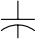 CL = 15 pF

RS

+
50 Ω V(Rs)
–

R Output
V CC
V(Rs) 1.5 V
0 V t(WAKE)
1.3 V
Figure 8. t(WAKE) Test Circuit and Voltage Waveforms

PARAMETER MEASUREMENT INFORMATION
0 Ω, 10 kΩ or
100 kΩ ±5%
DUT
RS
D
VI

R
+
VO 15 pF ±20%
CANH
60 Ω ±1%
CANL

50% 50%

50% 50%
VI

t(LOOP2)

VO
V CC
0 V

V OH

VOL
t(LOOP1)
Figure 9. t(LOOP) Test Circuit and Voltage Waveforms
NOTE: All VI input pulses are supplied by a generator having the following characteristics: tr or tf≤ 6 ns, Pulse Repetition Rate (PRR) = 125 kHz, 50% duty cycle

TYPICAL CHARACTERISTICS

SUPPLY CURRENT (RMS)
vs
FREQUENCY
ICC– Supply Current (RMS) – mA
33
32

31
30
29

28
27
26
25

0 250 500 750 1000 1250 1500 1750 2000
f – Frequency – kbps
Figure 10

BUS INPUT CURRENT
vs
BUS INPUT VOLTAGE
I I – Bus Input Current – μ A
400
300

200
100
0
–100

–200

–300

–400
–7 –6 –4 –3 –1 0 1 3 4 6 7 8 10 11 12

 |  |  |  |  |  | V
 |  |  |  | V CC | = 0
 |  |  |  |  |  | VC |  | C = 3 | .6 V

VI – Bus Input Voltage – V Figure 12

I I(L) – Log ic Input Current – μ A
–4

–6

–8

–10

–12

–14

–16
0 0.6 1.1 1.6 2.1 2.6 3.1 3.6
VI – Input Voltage – V
LOGIC INPUT CURRENT (PIN D)
vs
INPUT VOLTAGE
0
Figure 11
–2

DRIVER LOW-LEVEL OUTPUT CURRENT
vs
LOW-LEVEL OUTPUT VOLTAGE
I OL– Driver Low-Leve l Output Current – mA
160

140

120

100

80

60

40

20

0
0 1 2 3 4
VO(CANL)– Low-Level Output Voltage – V
Figure 13

TYPICAL CHARACTERISTICS

DRIVER HIGH-LEVEL OUTPUT CURRENT
vs
HIGH-LEVEL OUTPUT VOLTAGE
I OH – Driver High-Leve l Output Current – mA
120

100

80

60

40

20

0
0 0.5 1 1.5 2 2.5 3 3.5
VO(CANH) – High-Level Output Voltage – V Figure 14

RECEIVER LOW-TO-HIGH PROPAGATION DELAY TIME
vs
tP LH – Rece iver Low-to-High Propagat ion De lay Time – ns
FREE-AIR TEMPERATURE

RS = 0

V CC = 3 V

V CC = 3.3 V
V CC = 3.6 V

–55 –40 0 25 70 85 125 TA – Free-Air Temperature – °C
38

37

36

35

34

33

32

31

30
Figure 16

DOMINANT VOLTAGE (VOD)
vs
FREE-AIR TEMPERATURE
VOD– Dominant Vo ltage – V
0
–55 –40 0 25 70 85 125
TA – Free-Air Temperature – °C
Figure 15
V CC = 3.6 V
V CC = 3.3 V
V CC = 3 V
2

1.5

1
3

2.5
0.5

RECEIVER HIGH-TO-LOW PROPAGATION DELAY TIME
vs
tP HL– Receiver High-to-Low Propagation Delay Time – ns
FREE-AIR TEMPERATURE

RS | =0
 |  | V | = 3.3 V
 |  | VC | C = 3.6 | V

39
40
CC = 3
V
V
38
CC
37

36

35

34
–55 –40 0 25 70 85 125
TA – Free-Air Temperature – °C
Figure 17

TYPICAL CHARACTERISTICS

DRIVER LOW-TO-HIGH PROPAGATION DELAY TIME
vs
FREE-AIR TEMPERATURE
tP LH – Driver Low-to-High Propagat ion De lay Time – n
s
V CC = 3.6 V

–55 –40 0 25 70 85 125
TA – Free-Air Temperature – °C
V CC = 3 V

V CC = 3.3 V
55
50
45
40
35
30
25
20
15
10
Figure 18
RS = 0

DRIVER LOW-TO-HIGH PROPAGATION DELAY TIME
vs
FREE-AIR TEMPERATURE
tP LH – Driver Low-to-High Propagat ion De lay Time – ns
RS = 10 kΩ

V CC = 3 V

V CC = 3.6 V
TA – Free-Air Temperature – °C Figure 20
90
80
70
60
50
40
30
20
10
0
–55 –40 0 25 70 85 125
V CC = 3.3 V

DRIVER HIGH-TO-LOW PROPAGATION DELAY TIME
vs
FREE-AIR TEMPERATURE
tP HL– Driver High-to-Low Propagat ion De lay Time – ns
RS = 0
V CC = 3.6 V

V CC = 3.3 V

V CC = 3 V

–55 –40 0 25 70 85 125
90

85

80

75

70

65

60

55

50
TA – Free-Air Temperature – °C
Figure 19

DRIVER HIGH-TO-LOW PROPAGATION DELAY TIME
vs
FREE-AIR TEMPERATURE
tP HL – Driver High-to-Low Propagat ion De lay Time – n
s
V CC = 3.3 V

V CC = 3 V

–55 –40 0 25 70 85 125
TA – Free-Air Temperature – °C Figure 21
150

140

130

120

110

100

90

80
V CC = 3.6 V
RS = 10 kΩ

TYPICAL CHARACTERISTICS

DRIVER LOW-TO-HIGH PROPAGATION DELAY TIME
vs
FREE-AIR TEMPERATURE
tP LH – Driver Low-to-High Propagat ion De lay Time – ns
RS = 100 kΩ
V CC = 3 V

V CC = 3.3 V

V CC = 3.6 V

–55 –40 0 25 70 85 125
TA – Free-Air Temperature – °C
Figure 22
800

700

600

500

400

300

200

100

0

DRIVER HIGH-TO-LOW PROPAGATION DELAY TIME
vs
FREE-AIR TEMPERATURE
tP HL– Driver High-to-Low Propagat ion De lay Time – ns
RS = 100 kΩ
V CC = 3.6 V

V CC = 3.3 V

V CC = 3 V

–55 –40 0 25 70 85 125
TA – Free-Air Temperature – °C
1000

950

900

850

800

750

700
Figure 23

DRIVER OUTPUT CURRENT
vs
SUPPLY VOLTAGE
IO – Driver Output Current – mA
g
50

40

30

20

10

0
1 1.5 2 2.5 3 3.5 4
V CC – Supply Voltage – V
Fi ure 24

DIFFERENTIAL DRIVER OUTPUT FALL TIME
vs
SOURCE RESISTANCE (Rs)
t f – Different ia l Driver Output Fa l l Time – μ s
V CC = 3.3 V V CC = 3.6 V

V CC = 3 V

0 50 100 150 200
Rs – Source Resistance – kΩ
1.50 1.40 1.30 1.20 1.10 1.00 0.90 0.80 0.70 0.60 0.50 0.40 0.30 0.20
0.10 0
Figure 25

3

2.5
V ref – Reference Vo ltage – V

2

1.5

1

0.5

0

TYPICAL CHARACTERISTICS
REFERENCE VOLTAGE
vs
REFERENCE CURRENT

 |  | V CC | = 3.6 | V
 |  |  | V CC | = 3 V
–50 –5 5 50
I ref – Reference Current – μA Figure 26

APPLICATION INFORMATION
This application provides information concerning the implementation of the physical medium attachment layer in a CAN network according to the ISO 11898 standard. It presents a typical application circuit and test results, as well as discussions on slope control, total loop delay, and interoperability in 5-V systems.

introduction
ISO 11898 is the international standard for high-speed serial communication using the controller area network (CAN) bus protocol. It supports multimaster operation, real-time control, programmable data rates up to 1 Mbps, and powerful redundant error checking procedures that provide reliable data transmission. It is suited for networking intelligent devices as well as sensors and actuators within the rugged electrical environment of a machine chassis or factory floor. The SN65HVD230 family of 3.3-V CAN transceivers implement the lowest layers of the ISO/OSI reference model. This is the interface with the physical signaling output of the CAN controller of the Texas Instruments TMS320Lx240x 3.3–V DSPs, as illustrated in Figure 27.

APPLICATION INFORMATION

TMS320Lx2403/6/7
3.3-V DSP
ISO 11898 Specification Implementation
Application Specific Layer

Embedded
CAN
Controller
Physical Medium Attachment
Medium Dependent Interface
Data-Link Layer
Physical Layer
Medium Access Control
Logic Link Control
Physical Signaling
CAN Bus-Line
SN65HVD230
Figure 27. The Layered ISO 11898 Standard Architecture
The SN65HVD230 family of CAN transceivers are compatible with the ISO 11898 standard; this ensures interoperability with other standard-compliant products.

application of the SN65HVD230
Figure 28 illustrates a typical application of the SN65HVD230 family. The output of a DSP’s CAN controller is connected to the serial driver input, pin D, and receiver serial output, pin R, of the transceiver. The transceiver is then attached to the differential bus lines at pins CANH and CANL. Typically, the bus is a twisted pair of wires with a characteristic impedance of 120 Ω, in the standard half-duplex multipoint topology of Figure 29. Each end of the bus is terminated with 120-Ω resistors in compliance with the standard to minimize signal reflections on the bus.

APPLICATION INFORMATION
CANTX/IOPC6 CANRX/IOPC7

D R
SN65HVD230

CANH CANL

CAN Bus Line
Electronic Control Unit (ECU)

TMS320Lx2403/6/7

CAN-Controller
Figure 28. Details of a Typical CAN Node

CAN Bus Line
CANL
120 Ω
120 Ω
ECU ECU ECU
1 2 n
CANH
Figure 29. Typical CAN Network
The SN65HVD230/231/232 3.3-V CAN transceivers provide the interface between the 3.3-V TMS320Lx2403/6/7 CAN DSPsand the differential bus line, and are designed to transmit data at signaling rates up to 1 Mbps as defined by the ISO 11898 standard.

features of the SN65HVD230, SN65HVD231, and SN65HVD232
The SN65HVD230/231/232 are pin-compatible (but not functionally identical) with one another and, depending upon the application, may be used with identical circuit boards.
These transceivers feature 3.3-V operation and standard compatibility with signaling rates up to 1 Mbps, and also offer 16-kV HBM ESD protection on the bus pins, thermal shutdown protection, bus fault protection, and open-circuit receiver failsafe. The fail-safe design of the receiver assures a logic high at the receiver output if the bus wires become open circuited. If a high ambient operating environment temperature or excessive output current result in thermal shutdown, the bus pins become high impedance, while the D and R pins default to a logic high.

APPLICATION INFORMATION
features of the SN65HVD230, SN65HVD231, and SN65HVD232 (continued)
The bus pins are also maintained in a high-impedance state during low V CC conditions to ensure glitch-free power-up and power-down bus protection for hot-plugging applications. This high-impedance condition also means that an unpowered node does not disturb the bus. Transceivers without this feature usually have a very low output impedance. This results in a high current demand when the transceiver is unpowered, a condition that could affect the entire bus.

operating modes
RS (pin 8) of the SN65HVD230 and SN65HVD231 provides for three different modes of operation: high-speed mode, slope-control mode, and low-power mode.

high-speed
The high-speed mode can be selected by applying a logic low to RS (pin 8). The high-speed mode of operation is commonly employed in industrial applications. High-speed allows the output to switch as fast as possible with no internal limitation on the output rise and fall slopes. The only limitations of the high-speed operation are cable length and radiated emission concerns, each of which is addressed by the slope control mode of operation. If the low-power standby mode is to be employed in the circuit, direct connection to a DSP output pin can be used to switch between a logic-low level (< 1 V) for high speed operation, and the logic-high level (> 0.75 V CC) for standby. Figure 30 shows a typical DSP connection, and Figure 31 shows the HVD230 driver output signal in high-speed mode on the CAN bus.

D | 1 8 | RS IOPF6
二  GND  二 | 2  7 | 二 一  CANH  二 | TMS320LF2406  or
V CC | 6  3 | 」CANL | TMS320LF2407
R L | 4 5 | 」Vref
Figure 30. RS (Pin 8) Connection to a TMS320LF2406/07 for High Speed/Standby Operation

APPLICATION INFORMATION high-speed (continued)
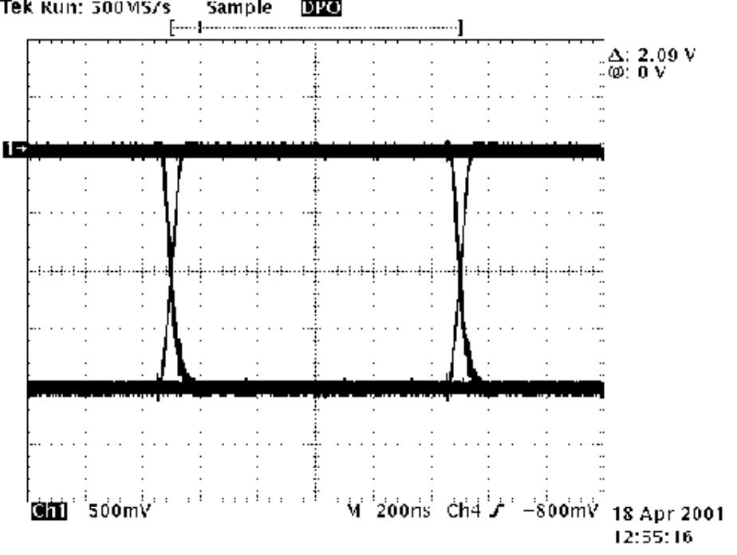

1 Mbps
Driver Output
NRZ Data

1
Figure 31. Typical High Speed SN65HVD230 Output Waveform Into a 60-Ω Load

slope control
Electromagnetic compatibility is essential in many applications using unshielded bus cable to reduce system cost. To reduce the electromagnetic interference generated by fast rise times and resulting harmonics, the rise and fall slopes ofthe SN65HVD230 and SN65HVD231 driver outputs can be adjusted by connecting a resistor from RS (pin 8) to ground or to a logic low voltage, as shown in Figure 32. The slope of the driver output signal is proportional to the pin’s output current. This slope control is implemented with an external resistor value of 10 kΩ to achieve a ≈ 15 V/μs slew rate, and up to 100 kΩ to achieve a ≈ 2.0 V/μs slew rate as displayed in Figure 33. Typical driver output waveformsfrom a pulse input signal with and without slope control are displayed in Figure 34. A pulse input is used rather than NRZ data to clearly display the actual slew rate.
10 kΩ to
D GND V CC
R
1  2  3  4 | 8  7  6  5 |  | RS |  | 100 kΩ | IOPF6 | TMS320LF2406  or  TMS320LF2407
 |  | 二  CAN  CAN  」Vref |  | H  L |  |  | TMS320LF2406  or  TMS320LF2407
Figure 32. Slope Control/Standby Connection to a DSP

APPLICATION INFORMATION

DRIVER OUTPUT SIGNAL SLOPE
vs
Driver Outout Signa l Slop – V/ μ s
SLOPE CONTROL RESISTANCE
25

20

15

10

5
0
0 .07 0.8 0 2520 00
Slope Control Resistance – kΩ
Figure 33. HVD230 Driver Output Signal Slope vs Slope Control Resistance Value

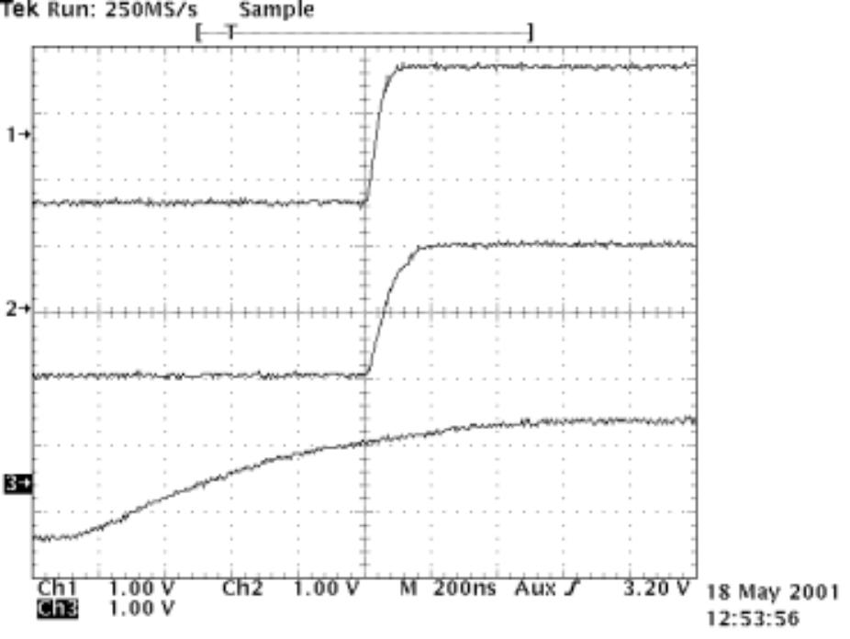
RS = 0 Ω

RS = 10 kΩ

RS = 100 kΩ

Figure 34. Typical SN65HVD230 250-kbps Output Pulse Waveforms With Slope Control

APPLICATION INFORMATION

standby mode (listen only mode) of the HVD230
If a logic high (> 0.75 V CC) is applied to RS (pin 8) in Figures 30 and 32, the circuit of the SN65HVD230 enters a low-current, listen only standby mode, during which the driver is switched off and the receiver remains active. In this listen only state, the transceiver is completely passive to the bus. It makes no difference if a slope control resistor is in place as shown in Figure 32. The DSP can reverse this low-power standby mode when the rising edge of a dominant state (bus differential voltage > 900 mV typical) occurs on the bus. The DSP, sensing bus activity, reactivates the driver circuit by placing a logic low (< 1.2 V) on RS (pin 8).

the babbling idiot protection of the HVD230
Occasionally, a runaway CAN controller unintentionally sends messages that completely tie up the bus (what is referred to in CAN jargon as a babbling idiot). When this occurs, the DSP can engage the listen-only standby mode to disengage the driver and release the bus, even when access to the CAN controller has been lost. When the driver circuit is deactivated, its outputs default to a high-impedance state.

sleep mode of the HVD231
The unique difference between the SN65HVD230 and the SN65HVD231 is that both driver and receiver are switched off in the SN65HVD231 when a logic high is applied to RS (pin 8). The device remains in a very low power-sleep mode until the circuit is reactivated with a logic low applied to RS (pin 8). While in this sleep mode, the bus-pins are in a high-impedance state, while the D and R pins default to a logic high.

loop propagation delay
Transceiver loop delay is a measure of the overall device propagation delay, consisting of the delay from the driver input to the differential outputs, plus the delay from the receiver inputs to its output.
The loop delay of the transceiver displayed in Figure 35 increases accordingly when slope control is being used. This increased loop delay means that the total bus length must be reduced to meet the CAN bit-timing requirements of the overall system. The loop delay becomes ≈ 100 ns when employing slope control with a 10-kΩ resistor, and ≈500 ns with a 100-kΩ resistor. Therefore, considering that the rule-of-thumb propagation delay of typical bus cable is 5 ns/m, slope control with the 100-kΩ resistor decreases the allowable bus length by the difference between the 500-ns max loop delay and the loop delay with no slope control, 70.7 ns. This equates to (500–70.7 ns)/5 ns, or approximately 86 m less bus length. This slew-rate/bus length trade-off to reduce electromagnetic interference to adjoining circuits from the bus can also be solved with a quality shielded bus cable.

APPLICATION INFORMATION

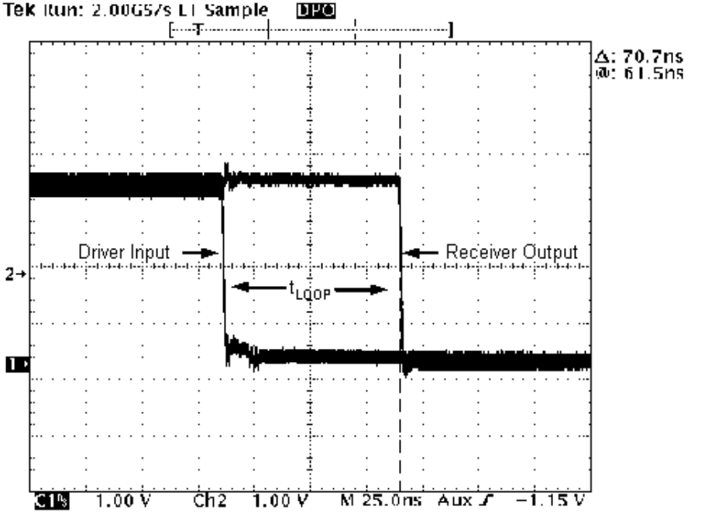
( )
Figure 35. 70.7-ns Loop Delay Through the HVD230 With RS = 0

APPLICATION INFORMATION

interoperability with 5-V CAN systems
It is essential that the 3.3-V HVD230 family performs seamlessly with 5-V transceivers because of the large number of 5-V devices installed. Figure 36 displays a test bus of a 3.3-V node with the HVD230, and three 5-V nodes: one for each of TI’s SN65LBC031 and UC5350 transceivers, and one using a competitor X250 transceiver.
One Meter Belden Cable #82841
120 Ω 120 Ω

SN65HVD230 SN65LBC031 UC5350 Competitor X250
Tektronix 784D
Trigger Oscilloscope Input
Tektronix
P6243
Single-Ended
Probes
Tektronix
HFS–9003
Pattern
Generator
HP E3516A
3.3-V Power
Supply
HP E3516A
5-V Power
Supply
Figure 36. 3.3-V/5-V CAN Transceiver Test Bed

APPLICATION INFORMATION

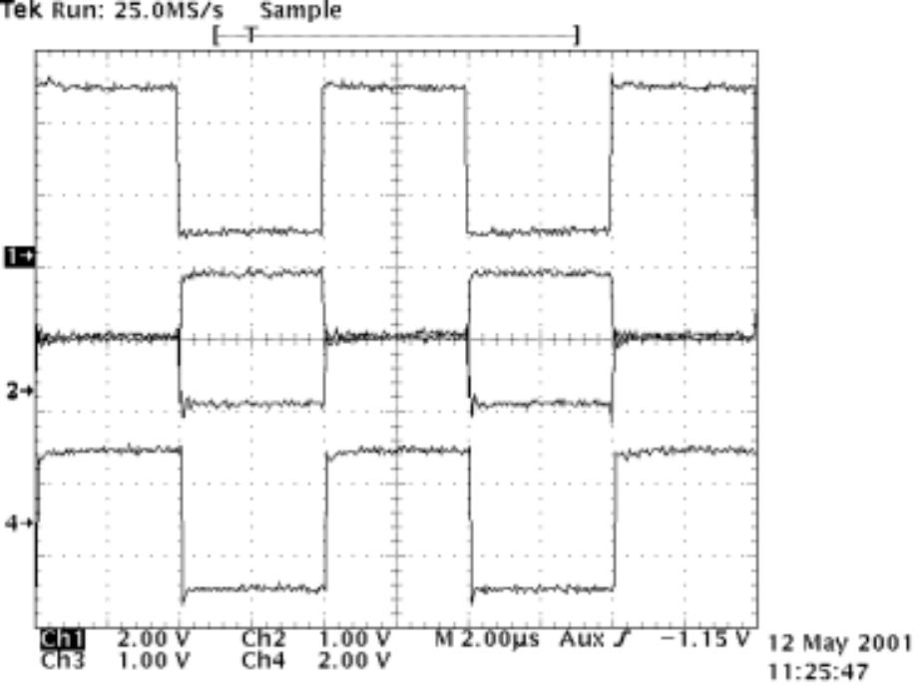

Driver Input

CAN Bus

Receiver Output

Figure 37. The HVD230’s Input, CAN Bus, and X250’s RXD Output Waveforms
Figure 37 displays the HVD230’s input signal, the CAN bus, and the competitor X250’s receiver output waveforms. The input waveform from the Tektronix HFS-9003 Pattern Generator in Figure 36 to the HVD230 is a 250-kbps pulse for this test. The circuit is monitored with Tektronix P6243, 1-GHz single-ended probes in order to display the CAN dominant and recessive bus states.
Figure 37 displays the 250-kbps pulse input waveform to the HVD230 on channel 1. Channels 2 and 3 display CANH and CANL respectively, with their recessive bus states overlaying each other to clearly display the dominant and recessive CAN bus states. Channel 4 is the receiver output waveform of the competitor X250.

MECHANICAL DATA

D (R-PDSO-G**) PLASTIC SMALL-OUTLINE PACKAGE
14 PINS SHOWN

0.010 (0,25) 0.004 (0,10)
Seating Plane
0.004 (0,10)
1

0.069 (1,75) MAX
0.008 (0,20) NOM

Gage Plane
0.050 (1,27)

14
0.244 (6,20) 0.228 (5,80)
0.157 (4,00) 0.150 (3,81)
0.010 (0,25)
0.044 (1,12) 0.016 (0,40)
7
A
0.020 (0,51)
0.014 (0,35)
8
0.010 (0,25) M
0°– 8°

PINS ** DIM | 8 | 14 | 16
A MAX | 0.197  (5,00) | 0.344  (8,75) | 0.394  (10,00)
A MIN | 0.189  (4,80) | 0.337  (8,55) | 0.386  (9,80)
4040047/ D 10/96
NOTES: A. All linear dimensions are in inches (millimeters).
B. This drawing is subject to change without notice.
C. Body dimensions do not include mold flash or protrusion, not to exceed 0.006 (0,15).
D. Falls within JEDEC MS-012

IMPORTANT NOTICE
Texas Instruments Incorporated and its subsidiaries (TI) reserve the right to make corrections, modifications, enhancements, improvements, and other changes to its products and services at any time and to discontinue any product or service without notice. Customers should obtain the latest relevant information before placing orders and should verify that such information is current and complete. All products are sold subject to TI’s terms and conditions of sale supplied at the time of order acknowledgment.
TI warrants performance of its hardware products to the specifications applicable at the time of sale in accordance with TI’s standard warranty. Testing and other quality control techniques are used to the extent TI deems necessary to support this warranty. Except where mandated by government requirements, testing of all parameters of each product is not necessarily performed.
TI assumes no liability for applications assistance or customer product design. Customers are responsible for their products and applications using TI components. To minimize the risks associated with customer products and applications, customers should provide adequate design and operating safeguards.
TI does not warrant or represent that any license, either express or implied, is granted under any TI patent right, copyright, mask work right, or other TI intellectual property right relating to any combination, machine, or process in which TI products or services are used. Information published by TI regarding third–party products or services does not constitute a license from TI to use such products or services or a warranty or endorsement thereof. Use of such information may require a license from a third party under the patents or other intellectual property of the third party, or a license from TI under the patents or other intellectual property of TI.
Reproduction of information in TI data books or data sheets is permissible only if reproduction is without alteration and is accompanied by all associated warranties, conditions, limitations, and notices. Reproduction of this information with alteration is an unfair and deceptive business practice. TI is not responsible or liable for such altered documentation.
Resale of TI products or services with statements different from or beyond the parameters stated by TI for that product or service voids all express and any implied warranties for the associated TI product or service and is an unfair and deceptive business practice. TI is not responsible or liable for any such statements.

Mailing Address:
Texas Instruments
Post Office Box 655303
Dallas, Texas 75265

Copyright ◎ 2002, Texas Instruments Incorporated

